## DP Map

Interactive Design Document

Version: 3.0

Date: 10/06/2018

Presented by: DP Map Team

|  |  |
| --- | --- |
| Team Member 1’s Name | Nathan Cramer |
| Team Member 2’s Name | Pierson Beckman |
| Team Member 3’s Name | Manuel Harvey |
| Team Member 4’s Name | Cameron Faubion |

# Revision History:

Revision 1: add wireframe images.

Revision 2: add wireframe description.

Revision 3: add storyboard.

# 2. Conceptual and Intermediate Design

## 2.1 Sketches and Storyboards

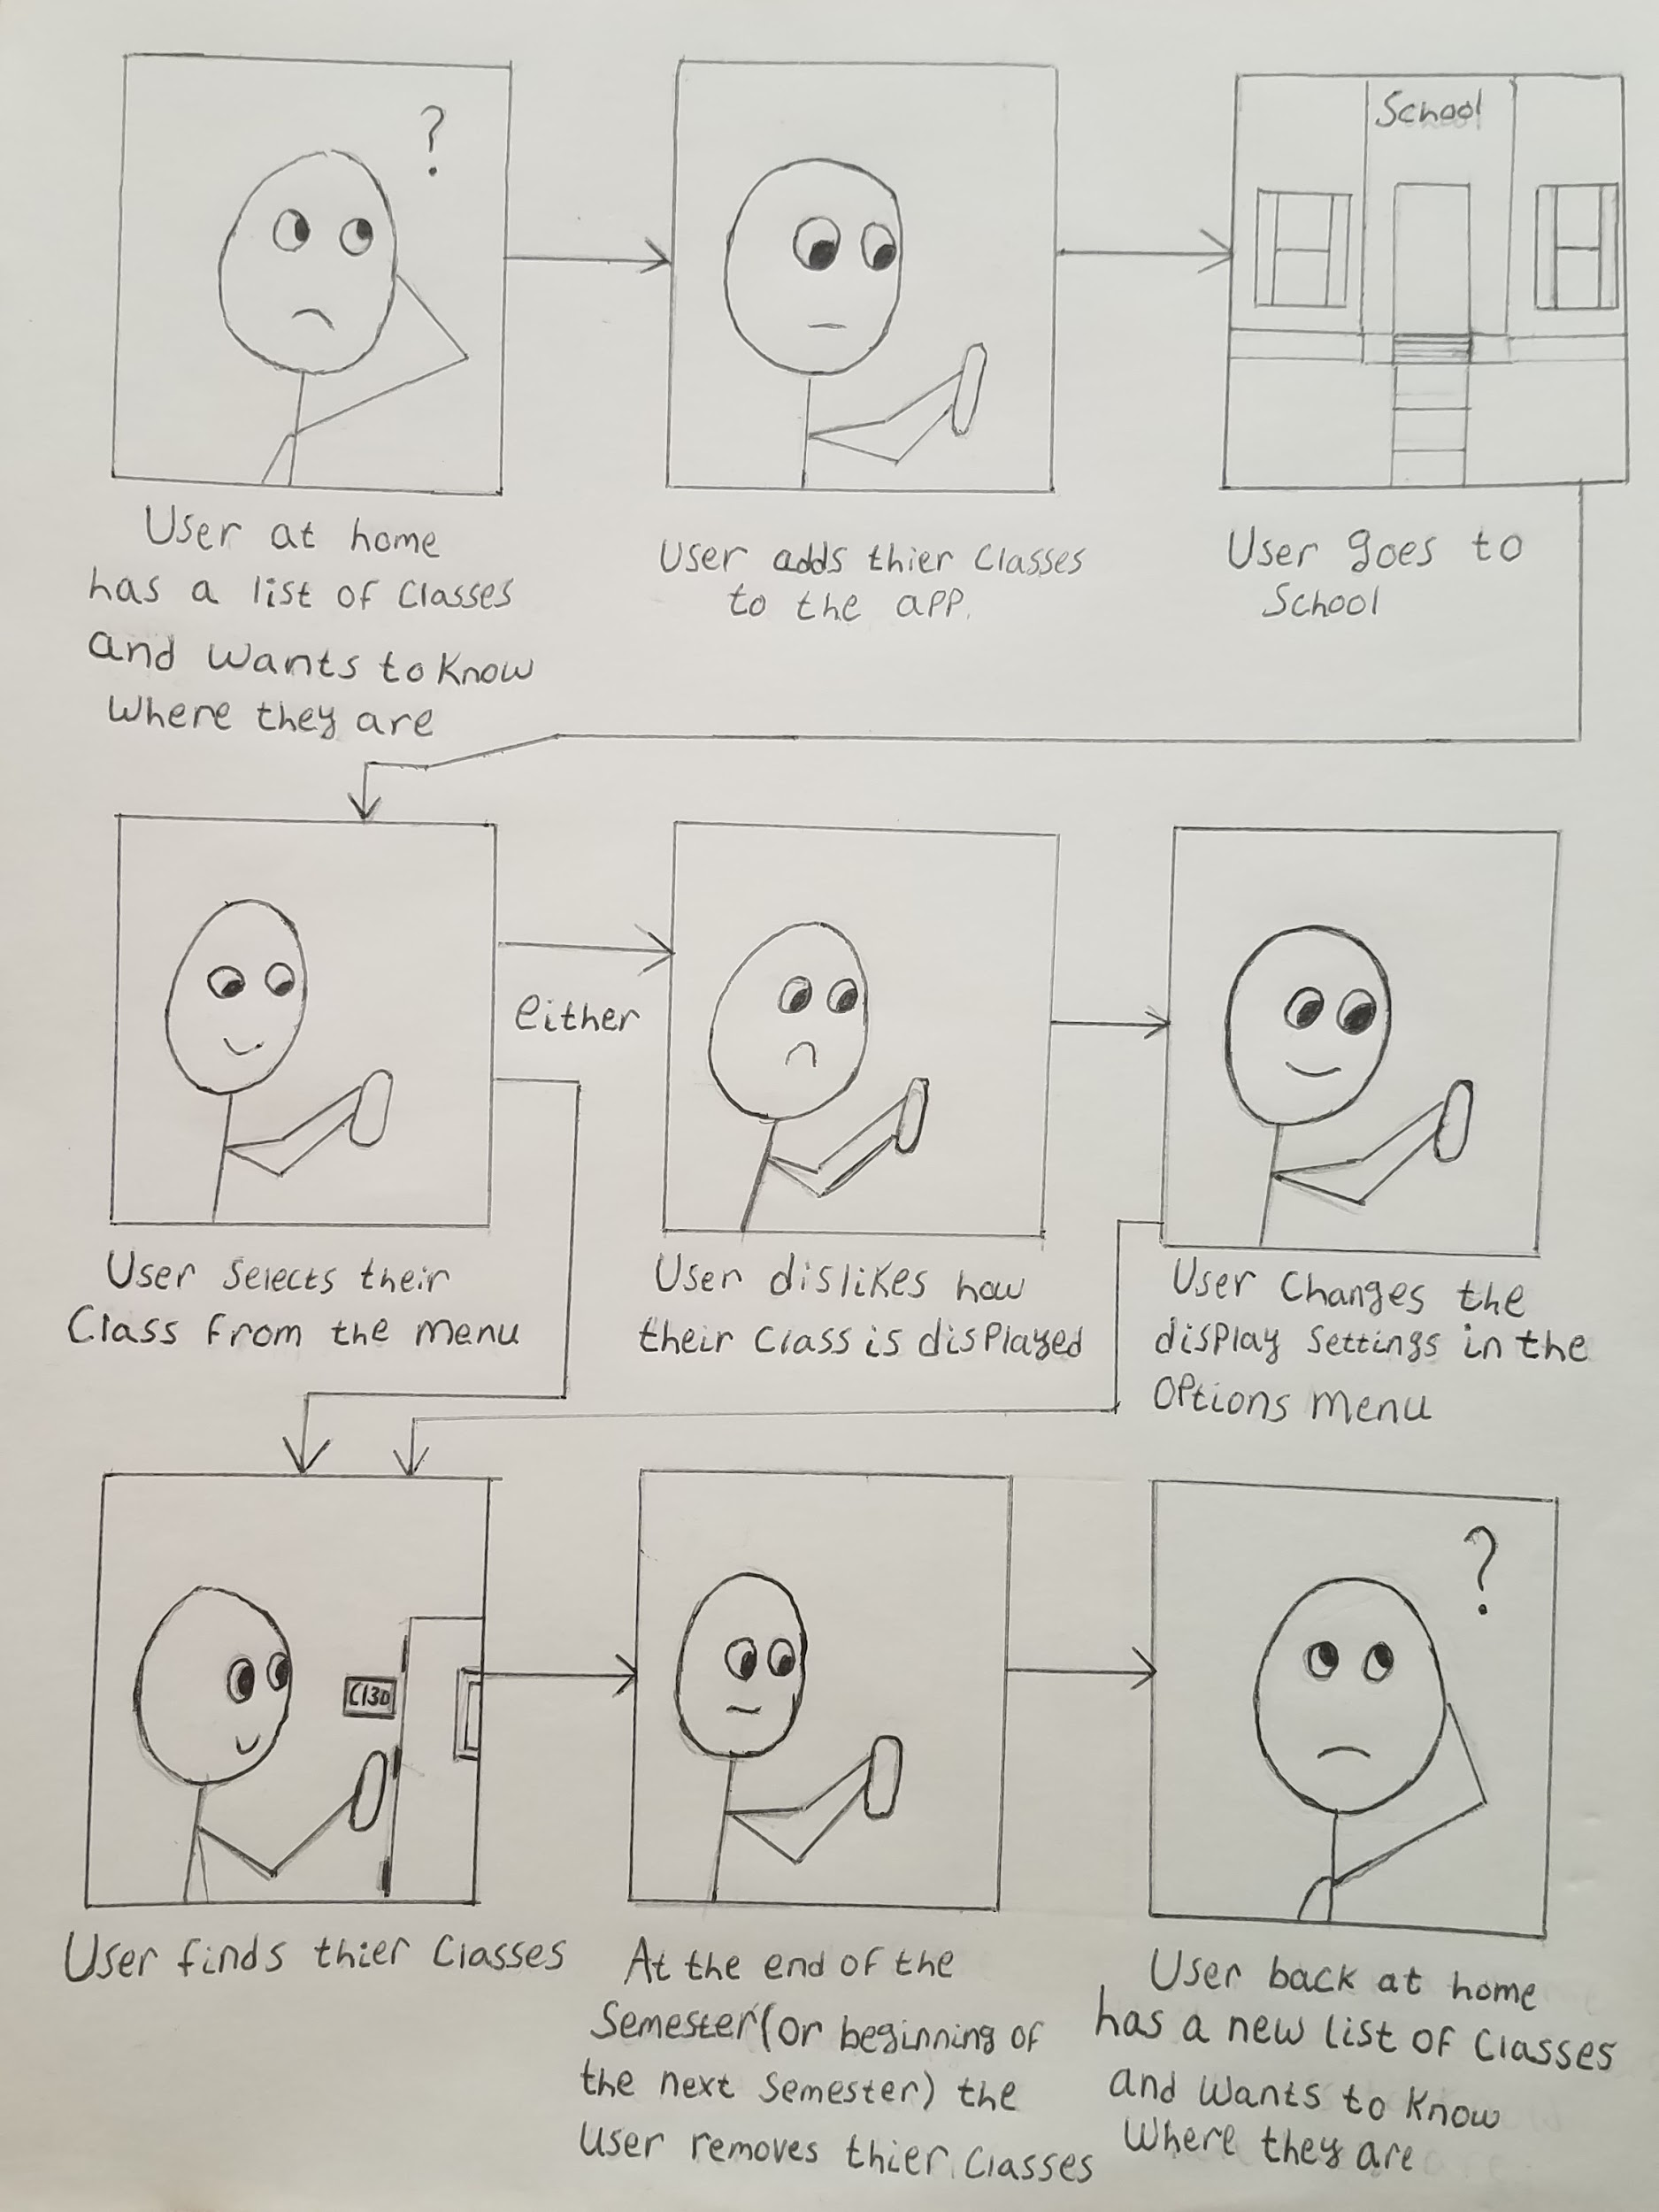

## 

## 

## 

## 

## 

## 

## 

## 2.2 Wireframes

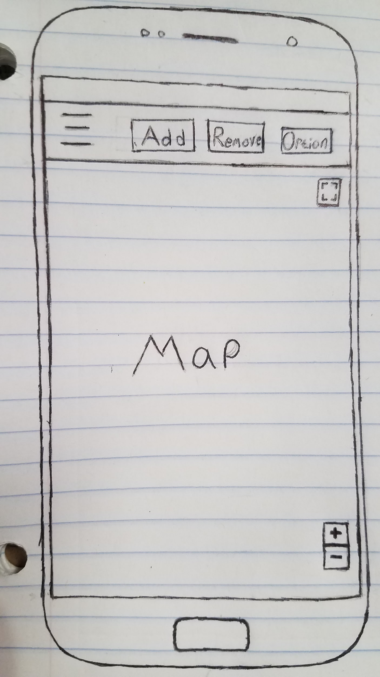

← This is the Wireframe for the main page of the app. The user will see this page when they start up the app.

The three horizontal lines will act as a dropdown menu for a toolbar that contains their list of classes. in the toolbar, the user will be able to select a class to highlight or pin its location on the map.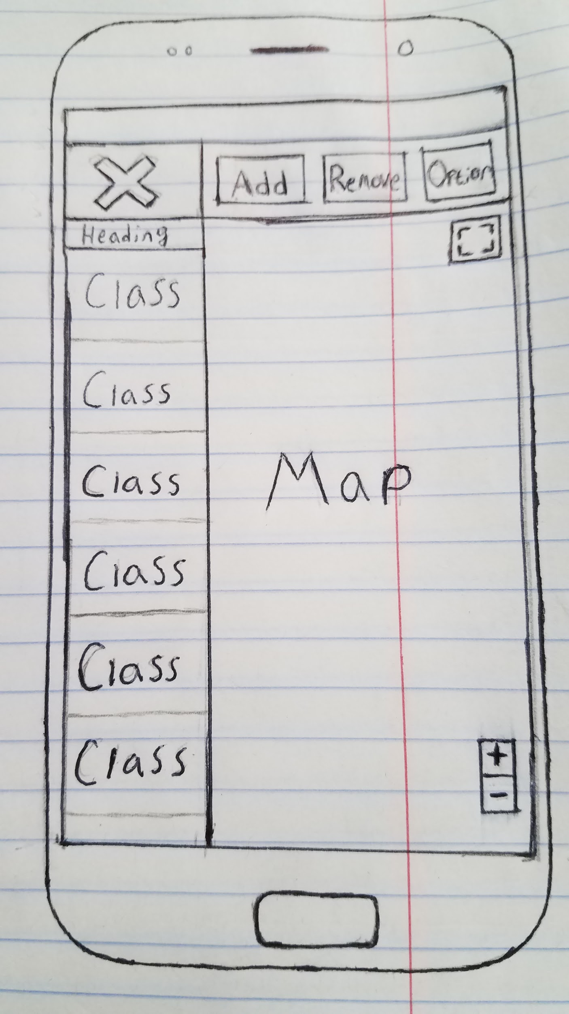

The image on the right shows what this toolbar will look like.

The little buttons on the right side of the map box are optional and will be added to support zoom functions or full screen support if they are deemed necessary in later iterations of development.